**EXPERIMENT NO.9**

AIM: To design a 4-bit adder subtractor.

IC USED: 7483A (4-bit adder), 7486(X-OR).

THEORY:

It is a combinational circuit which can act as both a binary adder and a binary subtractor. It is constructed using 4 full adders.Block diagram of the circuit is shown below:

In this case if sub is 0, then the circuit acts as an adder,else subtractor. Subtraction is done by adding two’s compliment of B to A, which effectively results in A - B.

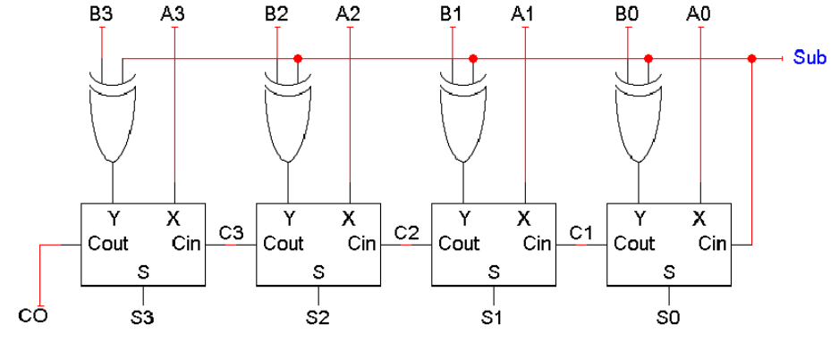

SCHEMATIC:

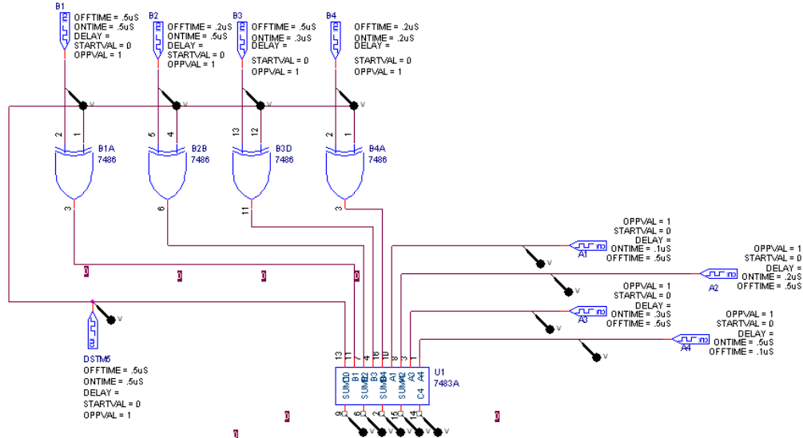

WAVEFORM:

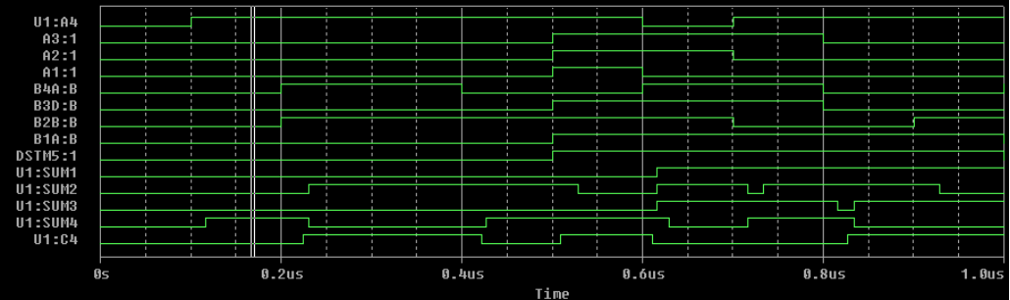

RESULT: The circuit of a 4-Bit adder subtractor is designed and verified.